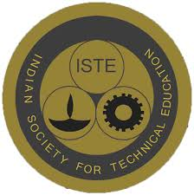
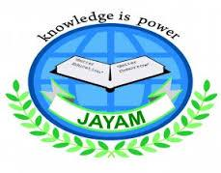
JAYAM COLLEGE OF ENGINEERING & TECHNOLOGY
DHARMAPURI
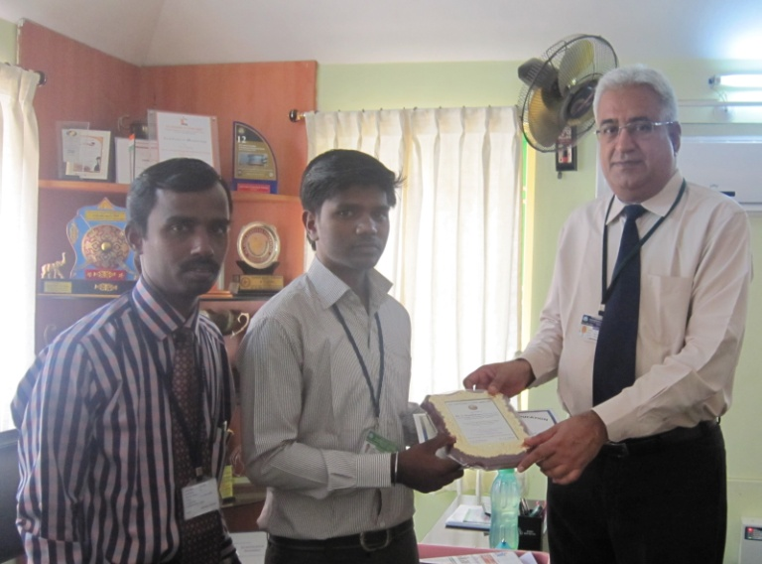
CONGRATULATORY MESSAGE
Selvan A.Kanal Arasu final year student in the Department of Civil Engineering has been awarded with the ISTE –BEST STUDENT AWARD FOR THE YEAR OF 2014 IN TAMILNADU & PUDHUCHERRY SECTION for his overall performance in academics, extra curricular activities and involvement in the activities of ISTE CHAPTER of Jayam college of Engineering And Technology

Congratulations to A.Kanal Arasu on his achievement.

PRINCIPAL
Dr.S.Ramachandran

